**Pillar Tracking with Drift Correction and Grid Analysis**

*Xiaochun XU, Felix Margadant*

*Mechanobiology Institute, National University of Singapore*

*mbixxc@nus.edu.sg, mbifmm@nus.edu.sg*

**How to install the** [**PillarTracker**](https://imagej.net/PillarTracker) **plugins in** [**Fiji**](http://fiji.sc/Fiji)**?**

1). Update the plugins directly from the Fiji’s updater (*Help->Update…*).  The **PillarTracker** update site is: <http://sites.imagej.net/PillarTracker/>, please active it and then press “*OK”*, then “*Apply changes*”, Fiji will automatically download and install the plugin ‘*Pillar\_Tracker\_GUI.jar*’.

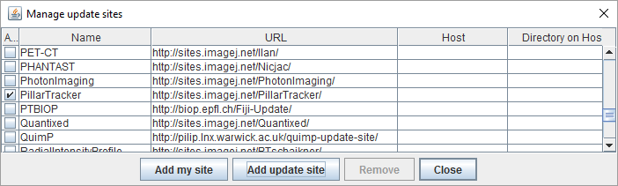

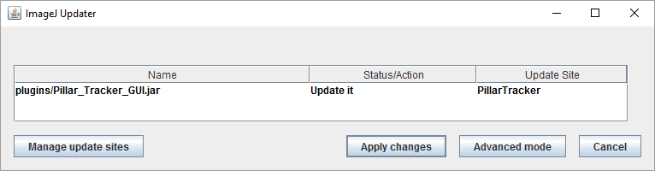

2). After installation, you can open the **PillarTracker** GUI from the menu (*Plugins->MBI-PillarTracker->Pillar Tracker GUI*). This software supports 64-bits Windows, Mac and Linux OS platforms.

**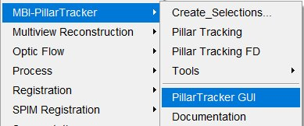**

3). The minimum requirements: 64-bits ImageJ core version 1.51h, Java version 1.8.60.

In general, the software will have the function of pillar detection, tracking, drift correction and grid creation. With this brand new GUI (Graphical User Interface), it will guide user to set the parameters, and visualize the data. ‘MDA\_pillar\_10sec\_15min\_\_R3D.dv’ is the exampled used here (images property of Prof. Sungsu Park).

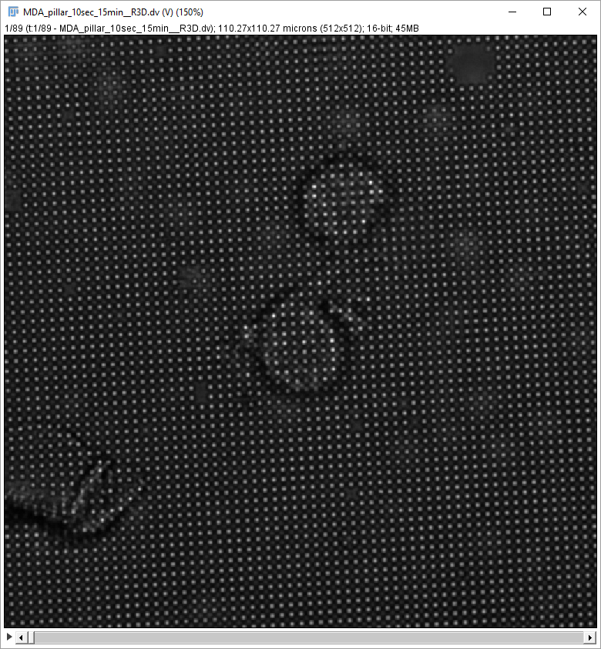

The new GUI will have four tabs to organize our steps of image processing and analysis in order:

1. **P**roperties (Ctrl + **P**)
2. **T**racking (Ctrl + **T**)
3. **D**rift Analysis (Ctrl + **D**)
4. **G**rid Analysis (Ctrl + **G**)

User can use the shortcut of combination keys to navigate tabs between each other.

Shortcut (Ctrl + **R**) can **R**un tracking or **R**ead files in current tab.

**Tab 1: Properties**

In this tab, the GUI will guide you to set **Pixel Size**, **Pillar Spacing**, **Angles**, **Diameter** and **Gaussian’s Sigma**.

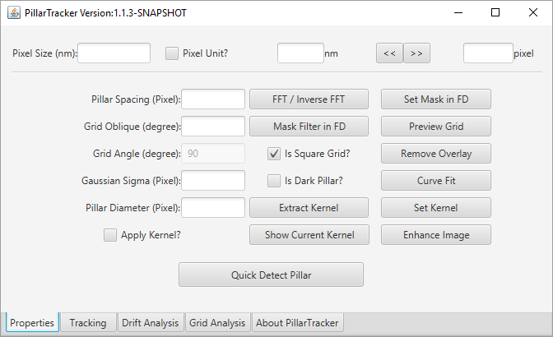

(1). How to set **Pixel Size**?

If current selected image has its own calibration information, which means its unit is in nm, um, or micron, such as here exampled image’s unit is in micron, tick the checkbox “*Pixel Unit?*”, the software will retrieve pixel size and automatically set it for you. Otherwise, you need firstly calibrate your image by setting its scale (*Analyze->Set Scale…*). After ticking this checkbox “*Pixel Unit?*”, the image status bar will show the current unit has been changed to the pixel unit. The software will not try to modify the original file. User can change it back to original unit by unchecking this checkbox.

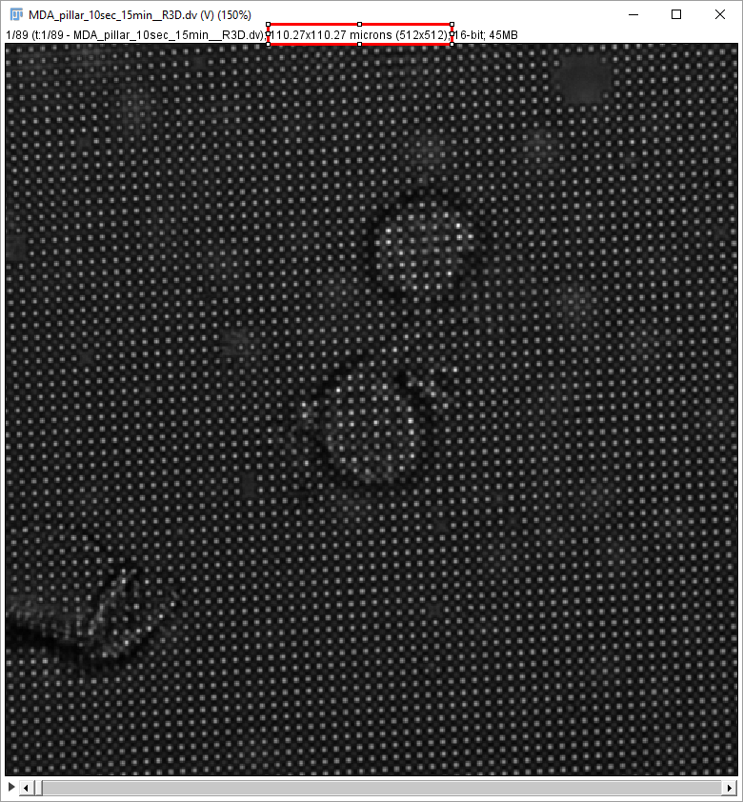

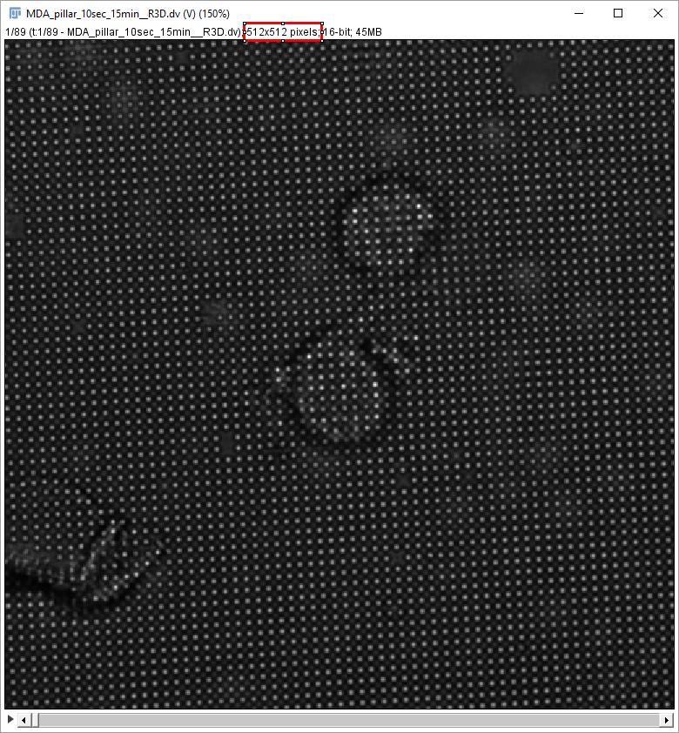

(2). How to set **Pillar Spacing**, **Grid Oblique** and **Grid Angle**?

**Pillar Spacing** is the separation between neighbor pillars (center-to-center distance). **Grid Oblique** angle is the rotation angle along image’s horizontal axis (also known as the X-axis). **Grid Angle** is the internal angle between pillar and its nearest neighbors in geometry, which determines how the pillars are arranged. There are two types commonly used in practice: square and equilateral triangle (known as BCC), which angle is 90 and 60 degrees, respectively.

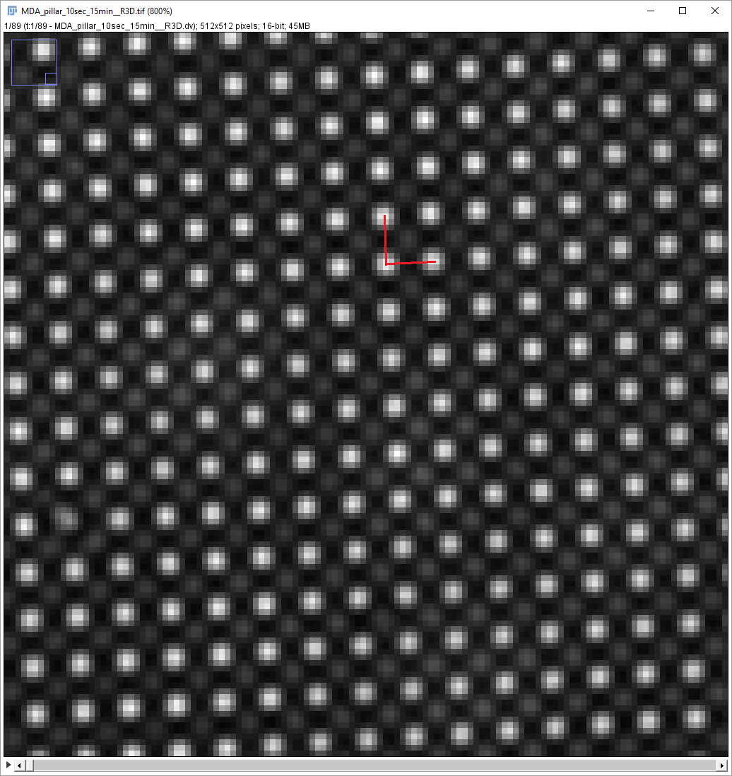 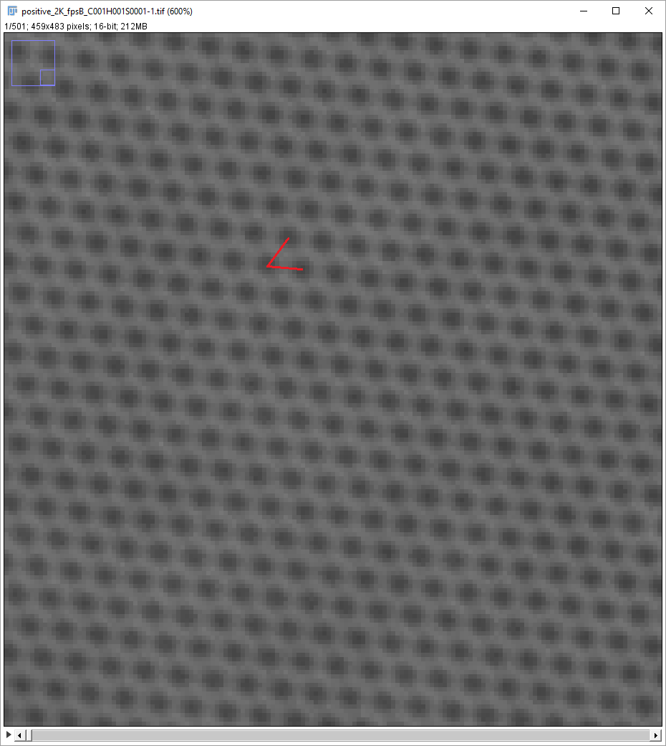

Because this periodic pillar pattern can be observed as peaks in frequency domain, FFT transformation is helpful to find out pillar spacing and grid oblique angle. The center of the FFT image is at the infinity frequency. The first peak on the right of center is the first-order frequency of the grid. From the ImageJ status bar, we can figure out spacing and grid oblique angle as measurements ***r*** and ***theta***, respectively. In a more accurate way, this peak can also be found out by “*Process->Find Maxima*”, then press shortcut “***Ctrl + M***” to show up the measurement table. The oblique angle can also be metric directly from the image in spatial domain by drawing a straight line crossing the pillars.

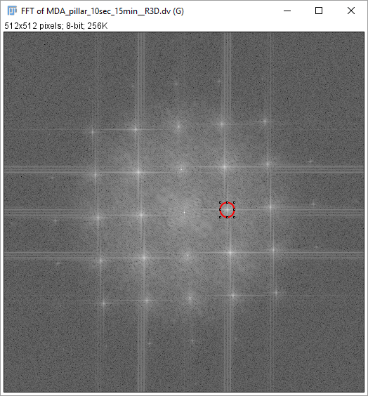 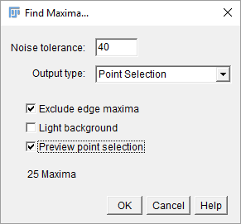

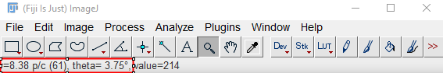

(3). How to set the **Pillar Diameter**?

**Pillar Diameter** is usual known when the pillars are fabricated, as well as the **Pillar Spacing**. If the image is scaled (or can be scaled) using **Pillar Spacing** (in another words, we know the **Pixel Size**!)**,**  then we can get **Diameter** by a simple unit conversion from *nm* to *pixel*. In particular, exampled image here, the **Pillar Diameter** is 800nm, with **Pixel Size** known as 215.38nm, equal with 3.714 pixels.

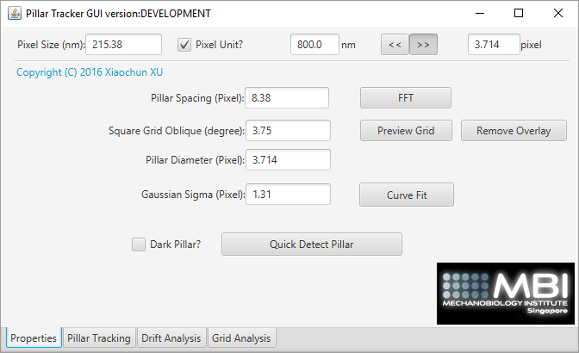

(4). How to set the **Gaussian Sigma**?

The **Gaussian Sigma $σ$** is the parameter that defines a 2-D parameterized Gaussian model.

$$G\left(x,y\right)= a*e^{\frac{{\left(x-x_{0}\right)}^{2}+{\left(y-y_{0}\right)}^{2}}{-2σ^{2}}}+b$$

Here, the parameter ***a*** is the amplitude, ***b*** is the background, (***x0, y0***) is the centroid. The parameter of Gaussian Sigma $σ$ can be pre-estimated by curve fit. Firstly, drawing a line crossing one clear pillar, then press the button “**Curve Fit**”, the software will present you the results of Gaussian fit (we only need the parameter “ ***d*** *”* in this curve figure, indicating **Gaussian Sigma $σ$** ), and then it will auto-set this parameter and decide whether the pillar is dark or bright. Please note that Gaussian Fit has the localization accuracy limit, described by Thompson’s formula *[Precise Nanometer Localization Analysis for Individual Fluorescent Probes]*.

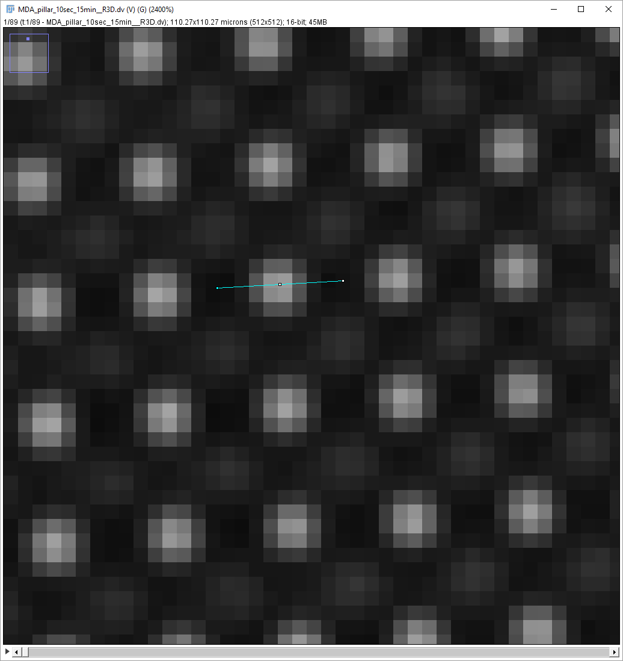 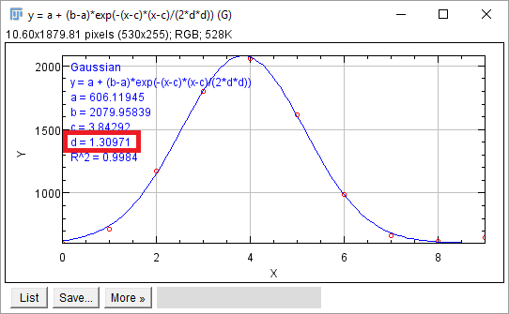

Until now, all parameters have been setup.

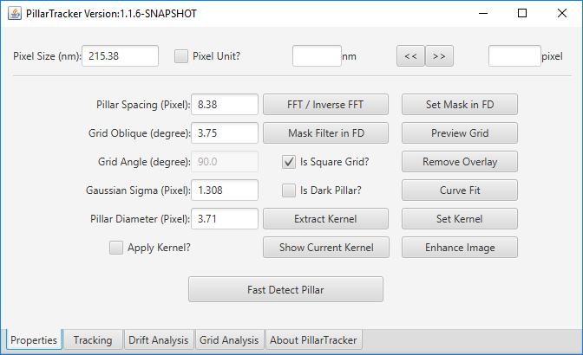

After all parameters set, it is better to detect the pillar and preview the grid to check the settings are reasonable. Press the button “*Quick Detect Pillar*”, software will try to identify the pillars and draw them with multi-point selection, which can be used as starting points for pillar tracking. This multi-point selection is editable (addition and deletion) in ImageJ.

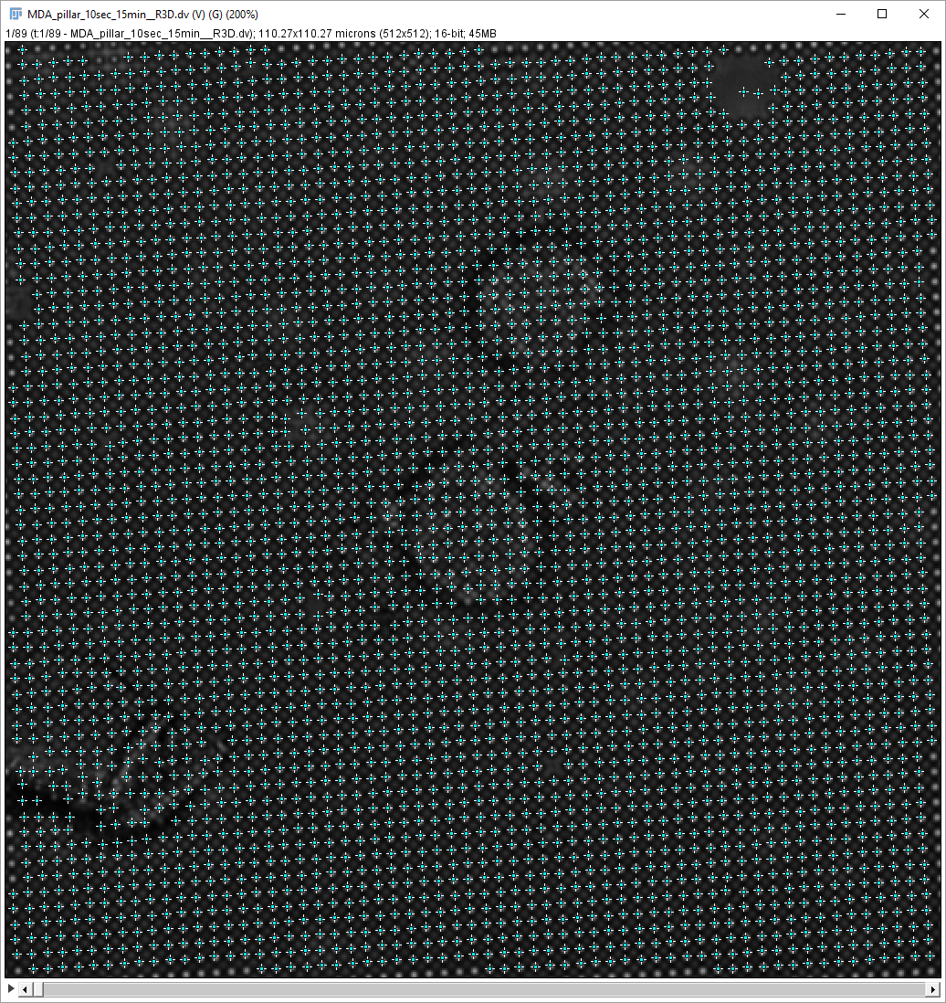

Please note that ImageJ itself also provides a very useful tool (*Process->Find Maxima*) to find the maxima, which can be used as the seed points for pillar tracking as well.

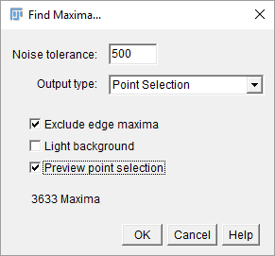

Press the button “*Preview Grid*”, software will draw the grid with no distortion assumed. If image has no point selections, a dialog will be promoted to request one point’s coordinate to start with.

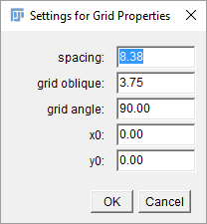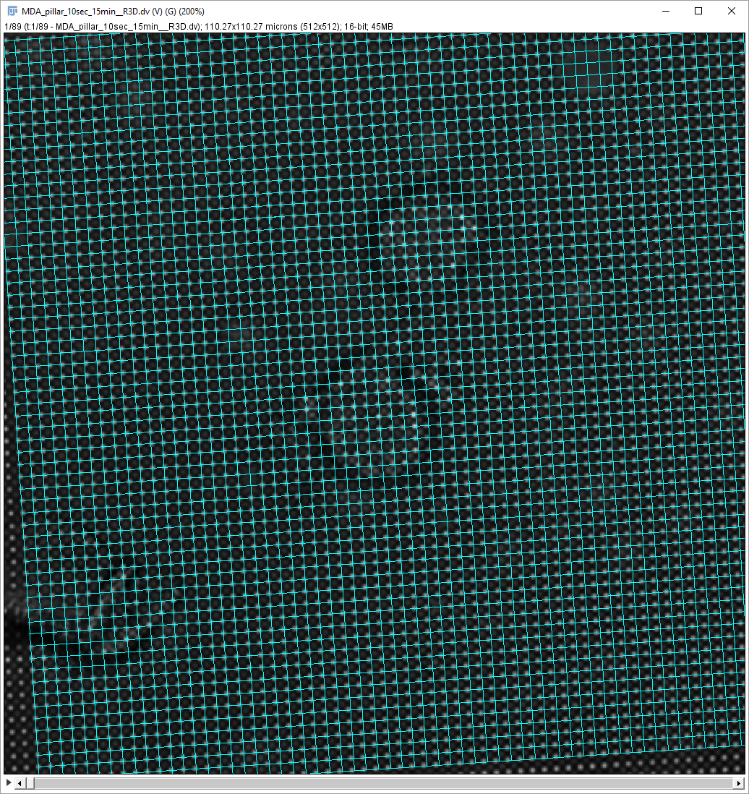

**Tab 2. Tracking**

In this tab, user needs to select a time series image in the combo box “***Input Image***” to track the pillars frame by frame. Tracking pillar will also use the parameters in **Properties** tab. The settings in this tab, **Search Window Width**, **Constrain Radius**, **Maximum Drift**, control the procedure of the tracking and optimization, and will be auto-set if you already valid the settings after pressing “*Quick Detect Pillar*”in **Properties** tab. For some scenario, it is better to make some more strict constrain, such as the data is too noisy or pillar is moving too fast.

This step implements pillar detection, tracking, drift correction, grid creation. We provide two localization algorithms, center of mass (CM) and Gaussian fit (GF).

1. 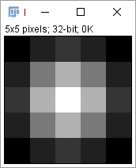The center of mass (CM) algorithm is very fast, at least 10 times faster than Gaussian Fit (GF) in principle, but has less accuracy than GF, and it is only reliable to an image without background. Please note that if your image has background, you must to find a way to reduce the influence of background to take advantage of CM. This plugin provides one way by computing cross correlation with a kernel for each pixel. The kernel is the 2-D profile of pillar, which can be extracted (the button “*Extract Kernel*”), set (the button “*Set Kernel*”) and applied (checkbox “*Apply Kerne?l*”) in the “**Properties**” tab. Kernel extraction supports sub-pixel centered alignment.
2. The Gaussian fit (GF) algorithm is using the Levenberg-Marquardt algorithm to fit a 2-D Gaussian model. It has no such background issue as the CM do, but the limitation is that the pillar shape must have Gaussian-like profile. It is time-consuming, but can be accelerated using multi-threading technology. The threads number has been auto-set to the number of CPU cores when the program started. Anti-virus software Kaspersky has been found that sometimes it prevents our program using multi threads. If the software is very slow, like several seconds per frame, you may need turn Kaspersky off.

From version 1.1.3, we introduce new pillar reconstruction algorithm, which is based on the high pass mask filter in frequency domain (FD). In order to set the masks, one can use the tool “*Process->Find Maxima*” to find out the peaks in its Fourier transformation image (FFT). And then press the button “*Set Mask in FD*” in the tab “**Properties**” to setup the off-center radius for the high pass mask filter.

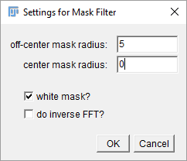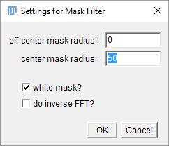

Here, white mask means the frequencies within this mask area will be “passed”, outside of this area will be “blocked”, while black one means the opposite. We just need the small white mask to reconstruct the pillars after its inverse FFT, which will remove the cell and restore the grid information as much as possible.

Interestingly, if we want to remove the grid, we can use a low pass filter only setting the center mask radius to a relatively large value, but not touch the grid’s peaks, e.g. set it to 50 here, After inverse FFT, we can get an image without the pillars. To reduce edge effects, a window function (e.g. Tukey Window) should be applied in spatial domain before FFT.

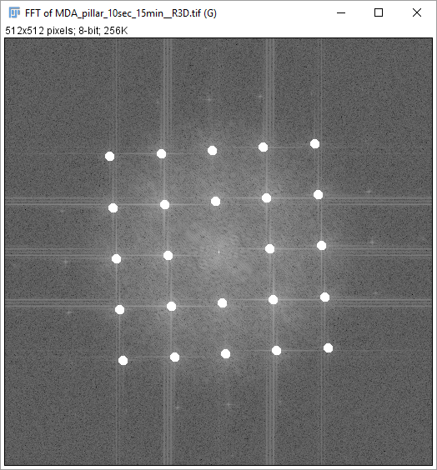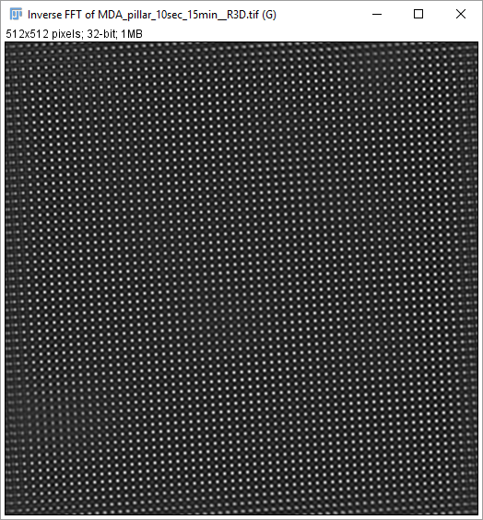

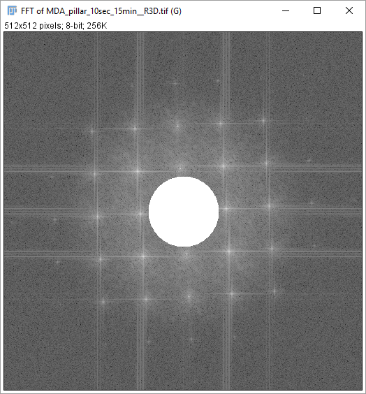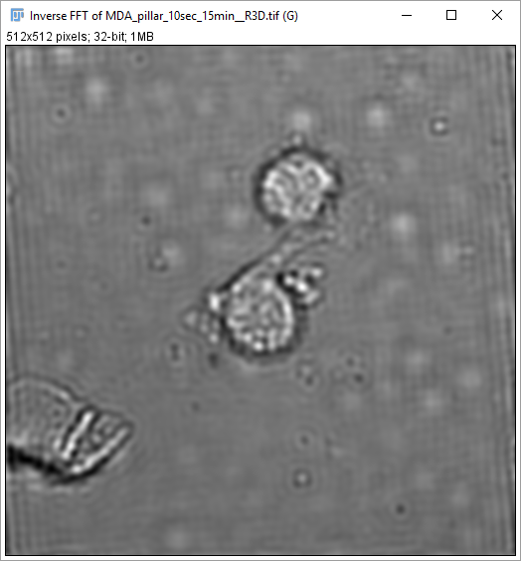

This algorithm has big advantage of creating accurate grid, compared with the old polynomial fit algorithm. In this way, we do not need to search the reference pillars to correct the drift or fit the distorted grid. Even if we process the image with very small region of interest, we do not have to worry about there are no enough reference pillars for drift correction and grid creation. We should notice that this method will not improve the localization accuracy, but it will improve the grid accuracy a lot, and much more robust. It will eventually replace the old one if the grid accuracy is our most concern.

In this “**Tracking**” tab, active the checkbox “*Restore Grid with Fourier Mask Filter?*” will enable this new feature. In order to localize totally relaxed (or unbent) pillars, we need set the off-center mask radius to a very small value. In practice, half of pillar spacing will be good enough to reconstruct the pillars.

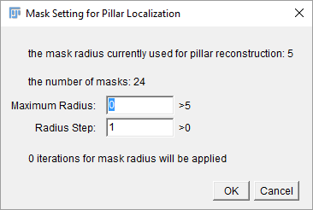

One way to see the influence of radius of off-center circle mask is to iterate this parameter by pressing the button “*Mask Filter in FD*” in tab “**Properties**”, disable the checkbox “*process all frames?*”, set “*end radius*” to a large value (e.g. 50), then click “OK”. The user will see a movie that the pillar moves to the bent position gradually with increasing this radius.

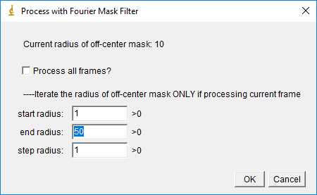

The Fourier mask filter is also useful to find out better profile of pillars, because the reconstructed pillars are homogenous reserved. From the reconstructed pillars, we can extract more accurate kernel (button “*Extract Kernel*” in tab “**Properties**”), and more accurate Gaussian’s sigma (button “*Curve Fit*” in tab “**Properties**”).

This software will also provide very useful tool to directly compute the drift and stabilize the image without tracking individual pillars. Right click in the “**Tracking**” accordion, and then click the menu “*Compute Drift & Stabilize*”.

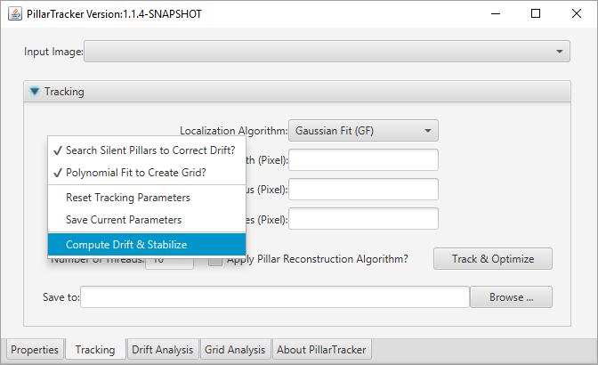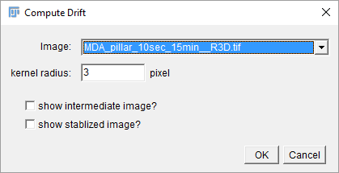

After tracking and optimization, the tracks and deflections will be wrote into files.

(1). Binary files for drift analysis, including tracks and drift information, and deflections if existed.

(2). CSV file, text version of tracks and deflections.

(3). Text file that contains parameters and drift information.

Binary Files (1) contains deflections information since version 1.1.3 if pillar reconstruction algorithm applied. These binary files are readable by any other programing language, e.g. Matlab, Python, or R. In case use would like to further process their data or do some sophistical statistical analysis on their own, we provide a Matlab script to load them into Matlab workspace as **Appendix 2**.

The paths of binary files will be auto filled up for the **Drift Analysis** and **Grid Analysis**. The settings will be also saved into the binary files. These settings can be loaded if “Drag & Drop” the binary files into the Tab “**Properties**”. Besides, in the tabs, “**Drift Analysis**” and “**Grid Analysis**”, the “Drag & Drop” feature is supported as well.

Right click “**Tracking**” accordion, and then click the menu “*Save Current Parameters*”, only current settings will be saved into a separate binary file with suffix “.profile” by default.

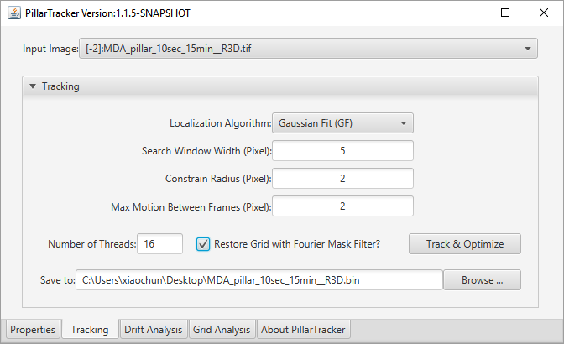

**Tab 3. Drift Analysis**

In this tab, the user can visualize the trajectories stored in a binary file (“.bin”) after tracking. This binary file normally has drift-corrected coordinates, with the stage movement compensated.

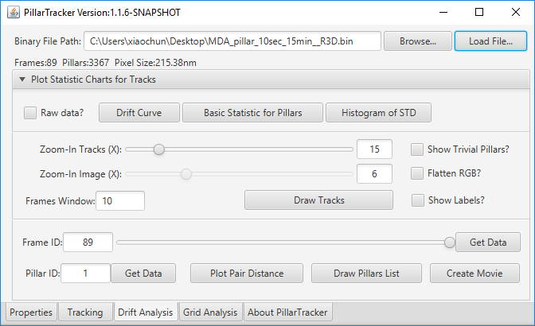

To visualize the trajectory of individual pillar’s movement (aka. **Tracks Map**), Press the button "*Draw Tracks*".

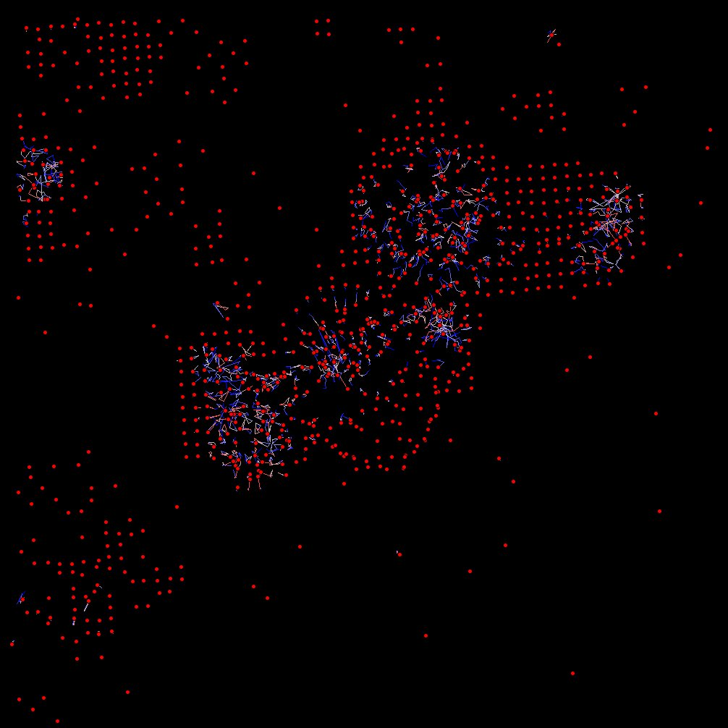

Tick the checkbox “*Show Labels?*”, then pillar indexes will show up in the **Tracks Map**.

To show the drift information, press the button “*Drift Curve*”.

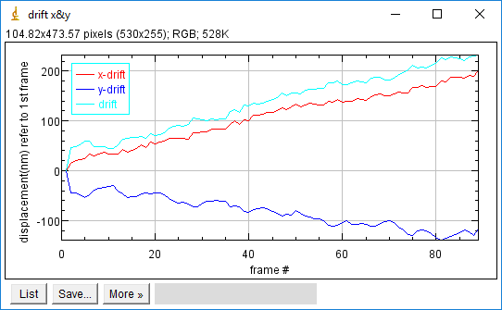

To get the basic statistic for pillars, e.g. average, standard deviation, press the button “*Basic Statistic for Pillars*”. A table “**Results**” will show up, and then a histogram can be created, if clicking the menu “*Results->Distribution…*” in the “**Results**” table as following.

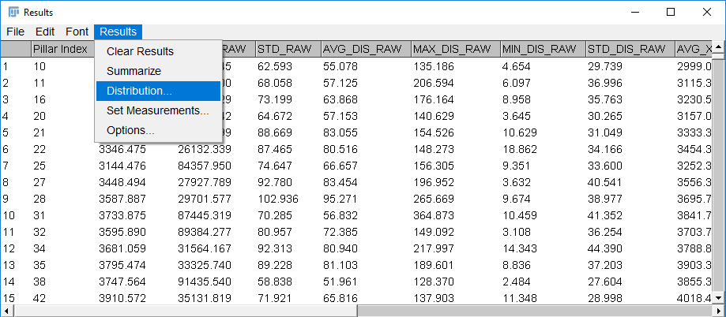

If want to show the drawings on original image, right click and then tick the menu “*Draw in Selected Image?*”, press the button “*Draw Tracks*” again to refresh **Tracks Map**.

H:\fiji_javafx\Pillar_Tracker_GUI\documentation_figures\MDA_pillar_10sec_15min__R3D.bin x2-1.0.tif 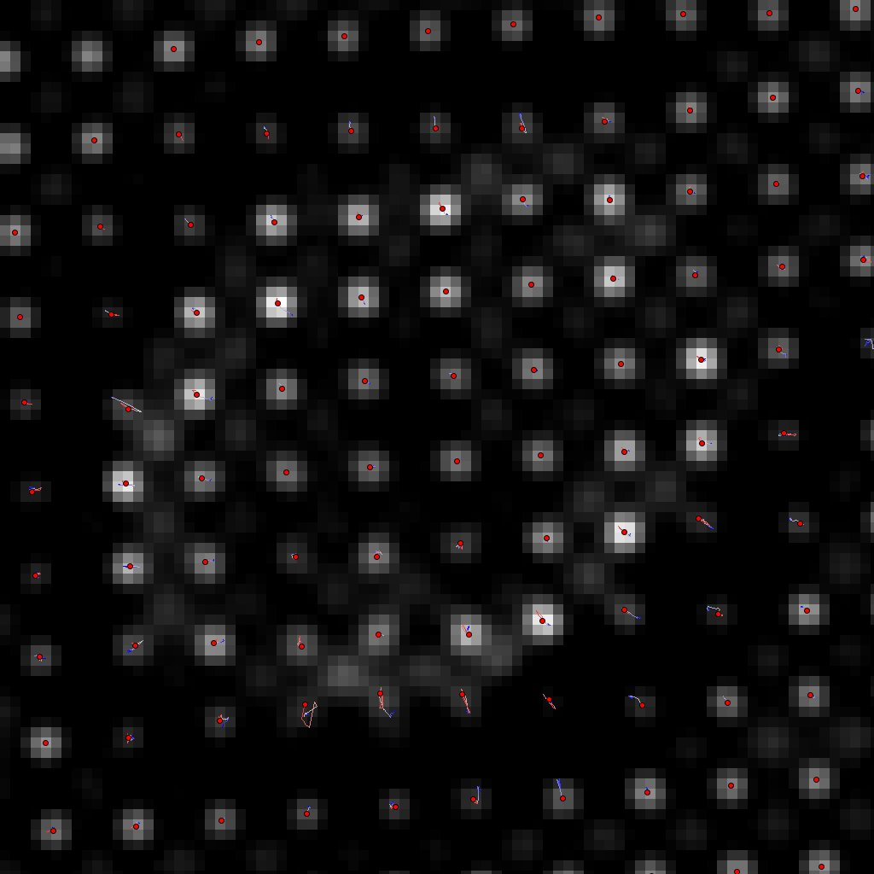

If want to restrict an interest region to analyze, draw an area selection and then press the button “*Draw Tracks*” again to refresh **Tracks Map**.

Right clicking the menu “*List the Shown Pillars*”, an indexes list of current selected pillars will show up as a table “*List of Pillars with Basic Statistic*”.

Right clicking the menu “*Get ROI Data for ALL Frames*”, the current selected pillars’ data (raw trajectories and deflections) for all frames will show up as a table “*Data for ALL Frames*”.

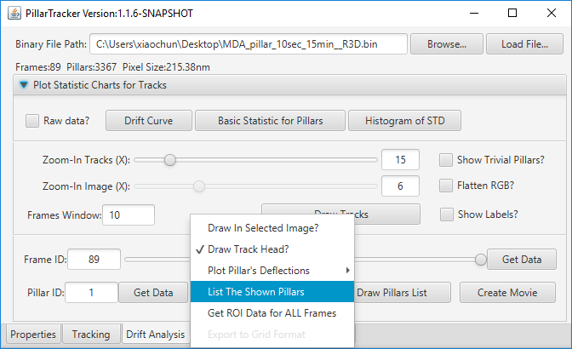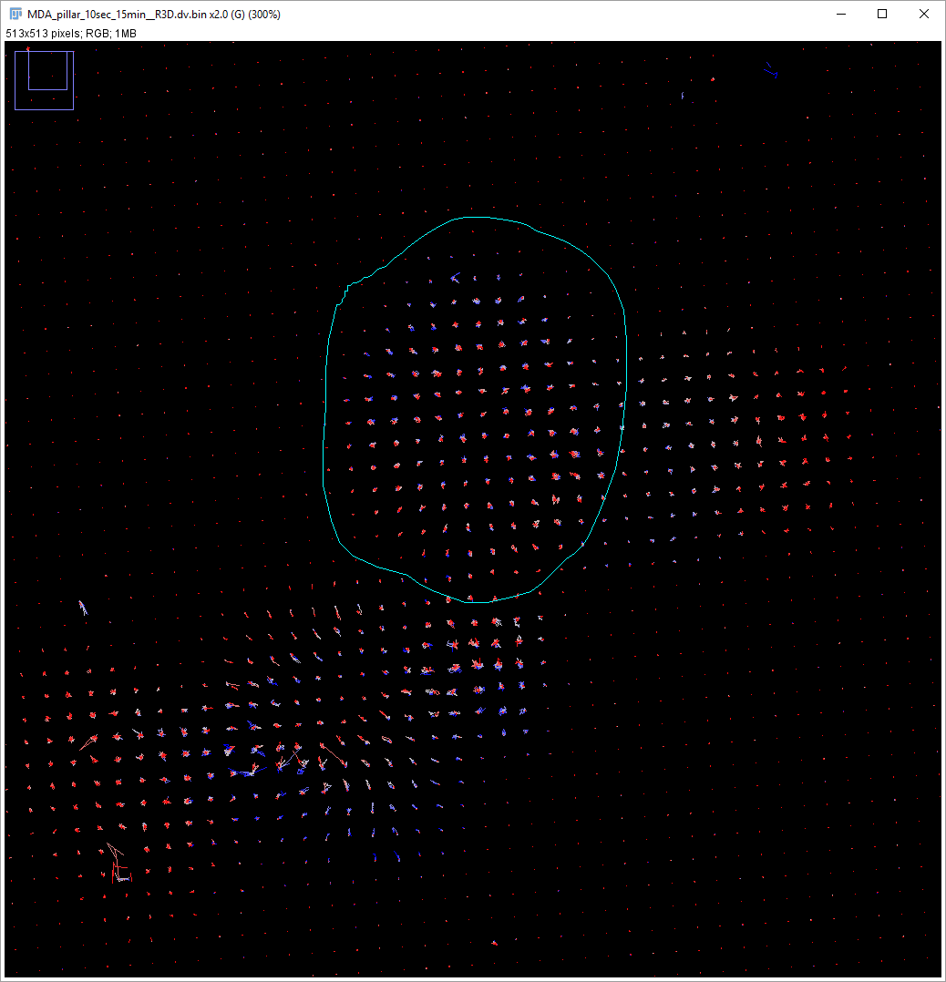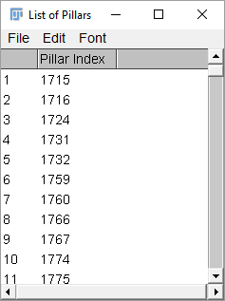

To get the data of the specified pillar with “*Pillar ID*”, for all over frames, press the button “*Get Data*” beside “*Pillar ID*” textbox.

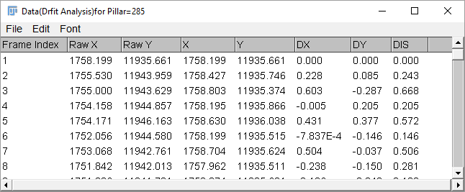

To get the data of current selected pillars in a specified frame with “*Frame ID*”, for all over pillars, press the button “*Get Data*” beside the “*Frame ID*” slider.

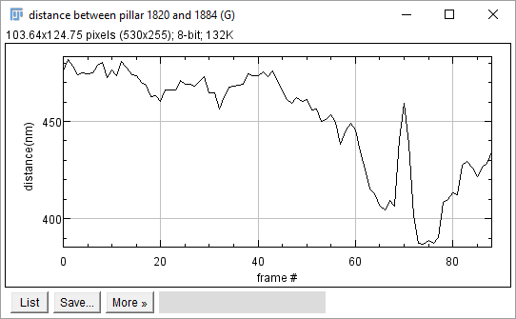To measure the distance of two pillars over time, press the button “*Plot Pairs Distance*”, then set up indexes of these two pillars which you intent to measure.

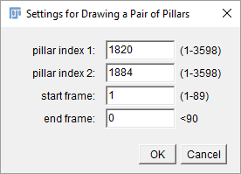

To snapshot the **Tracks Map**, click the menu (*Plugins->Utilities->Capture Image*).

To create a movie of **Tracks Map** over the time, press the button “*Create Movie*”.

If user does not apply the Fourier mask filter to create the grid, the software provides some ways to create the grid, e.g. polynomial fit or imported reference, by the menu "*Export to Grid Format*". This will generate a binary file, which can be imported in the Grid Analysis.

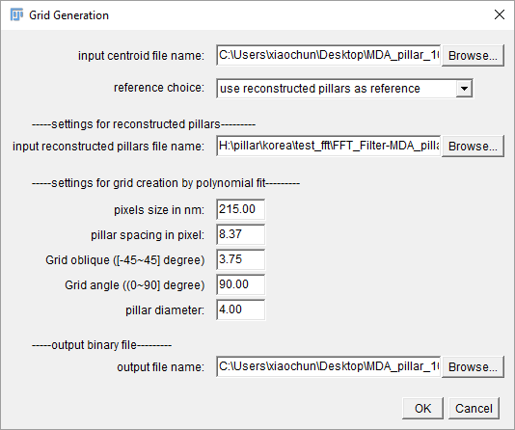

**Tab 4. Grid Analysis**

Here, We calculate deflections referring to the grid, so each pillar in each frame will have an absolute deflection $δ$, which is directly related to contracted or stretched force $F$ by [Euler-Bernoulli beam theory](https://en.wikipedia.org/wiki/Deflection_(engineering)):

Where is the Young’s modulus, $I$ is the [area moment of inertia of cross section](http://www.clag.org.uk/beam.html), and $L$ is the length of beam. If we know the pillar material, then we can quantitatively measure the force very easily. For example, [PDMS](http://www.mit.edu/~6.777/matprops/pdms.htm) Young’s Modulus $E$, 360-870 KPa, varying from different stiffness. For round section pillar, $I=πd^{4}/64$, here $d$ is the diameter of pillar. The Force will be

$$F= \frac{3πd^{4}E}{64L^{3}}δ$$

There is a demo of Matlab script ([demo\_force\_map.m](https://github.com/scottreen/PillarTracker/blob/master/matlab/demo_force_map.m)) on the GitHub to create an interpolated force map for each frame.

In this tab, to visualize the deflections frame by frame (aka. **Deflections Map**), press the button "*Draw Deflections*".

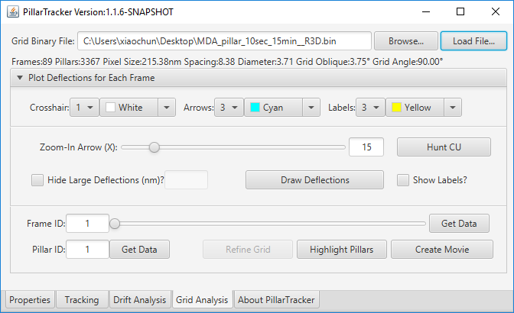

The user is free to change the size and color of the labels, crosshair, and arrows in **Deflections Map**.

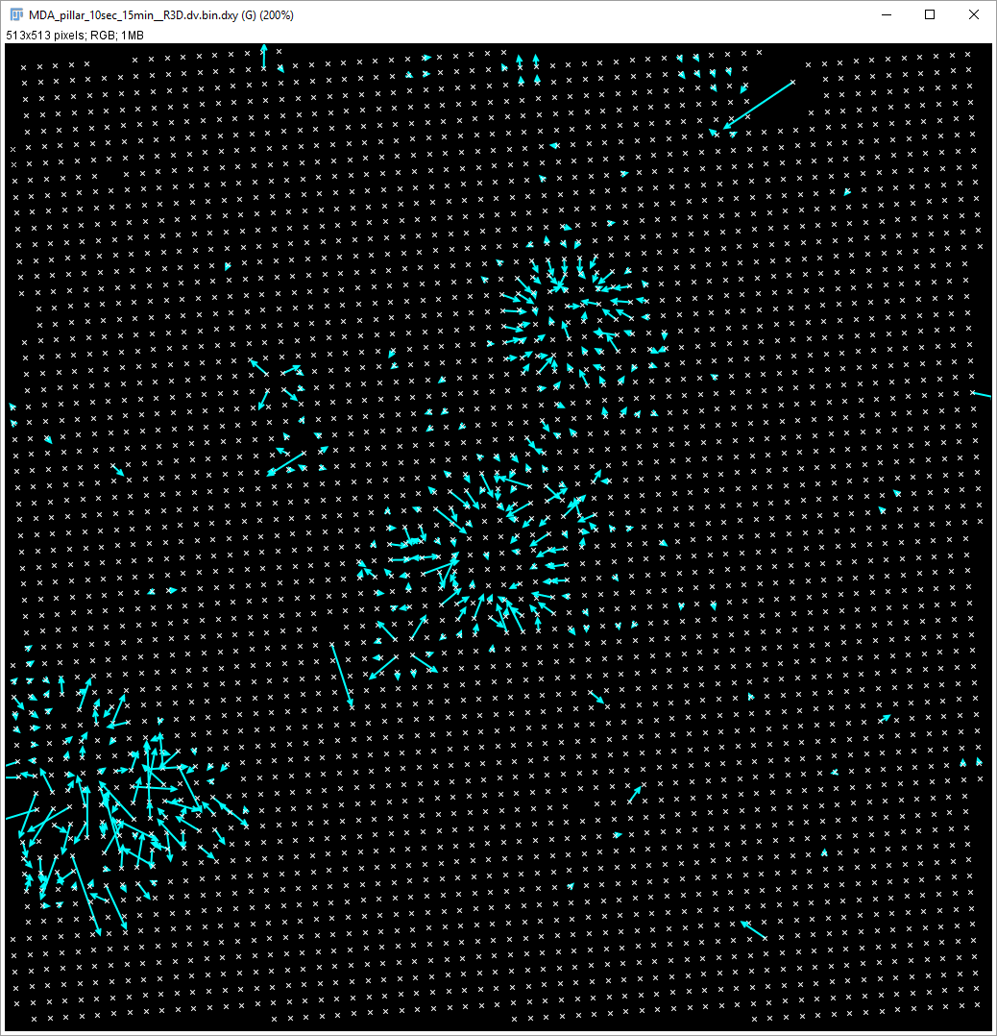

As well as the **Tracks Map**, to show the labels in **Deflections Map**, active the checkbox “*Show Labels?*”. The difference here is that label has two types: pillar index and deflection value.

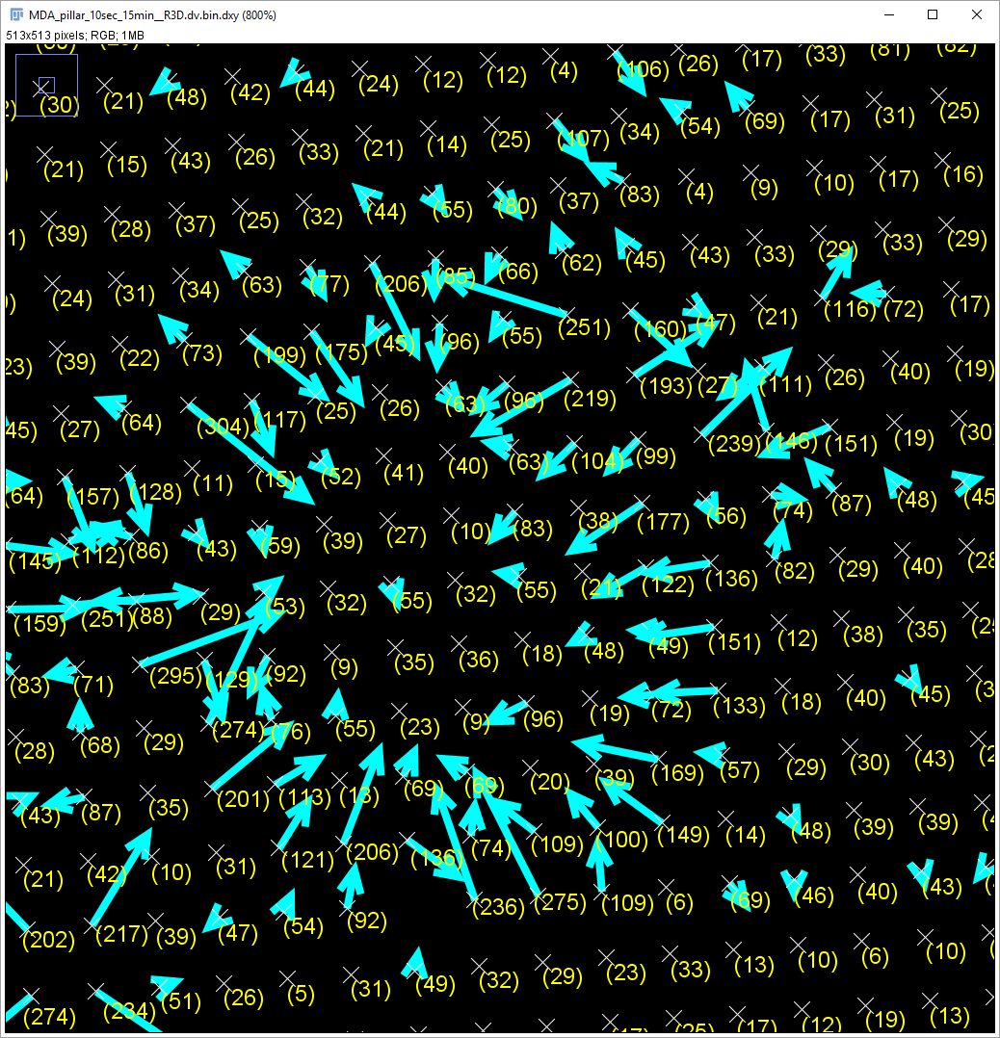 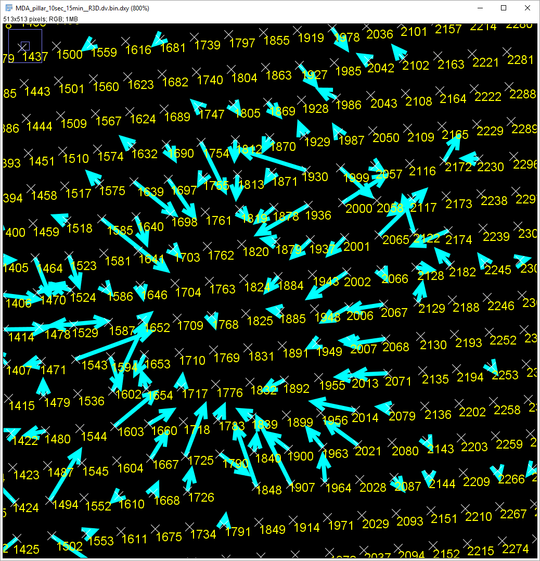

If want to only analyze an interest region, draw an area, and then press “*Draw Deflections*” to refresh the **Deflections Map** again.

Right clicking the menu “*Get ROI Data for ALL Frames*”, the current selected pillars’ data (raw trajectories and deflections) for all frames will show up as a table “*Data for ALL Frames*”.

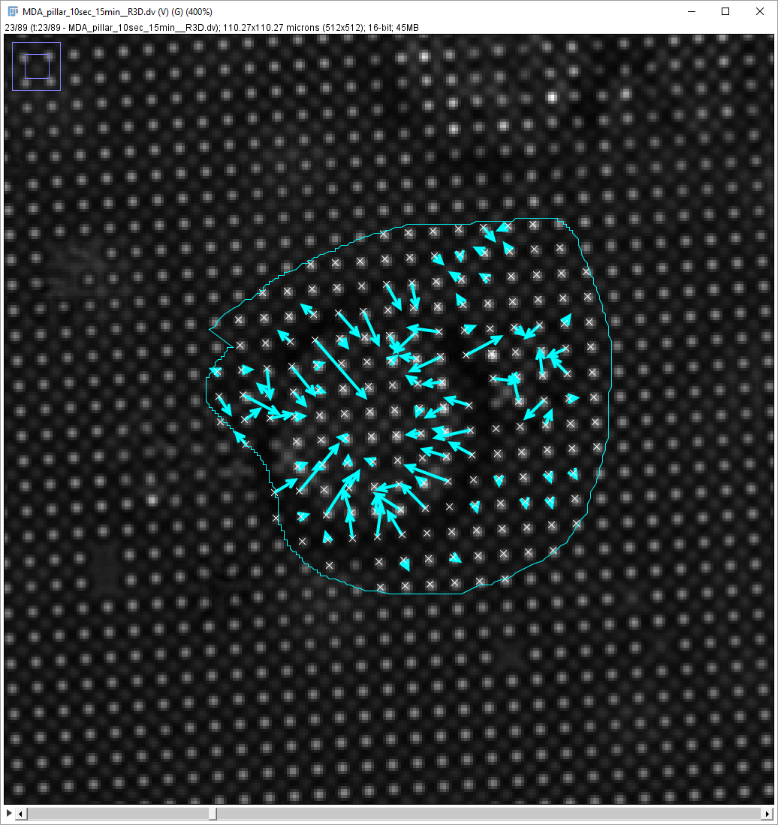

To get the data of current selected pillars in specified frame with “*Frame ID*”, press the button “*Get Data*” beside “*Frame ID*” slider.

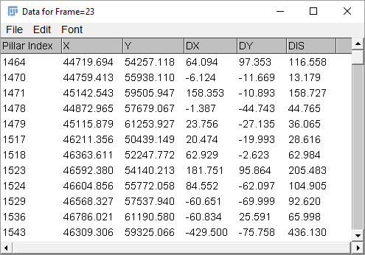

To get the data of specified pillar with “*Pillar ID*” for all over the frames, press the button “*Get Data*” beside “*Pillar ID*” textbox.

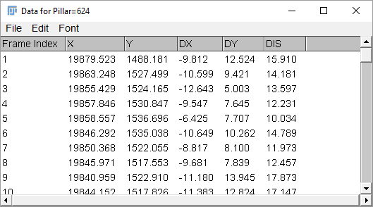

To snapshot the **Deflections Map**, click the menu (*Plugins->Utilities->Capture Image*).

To create a movie of **Deflections Map** over the time, press the button “*Create Movie*”.

Press the button “*Hunt CU*”, the software will try to search the contractile unit (CU). The user needs to set the radius to limit the neighbors to be caught, and the thresholds of correlation coefficient (**R**) in perpendicular (***p***) and orthogonal (***s***) projections on the axis of a pair pillars. As the CUs simultaneously pinch the pillars, which can be considered as anti-correlation behavior, so set the threshold ***Rp*** to a relative high negative (<-0.5). The frame window enables user to limit the interval time to search the pairs.

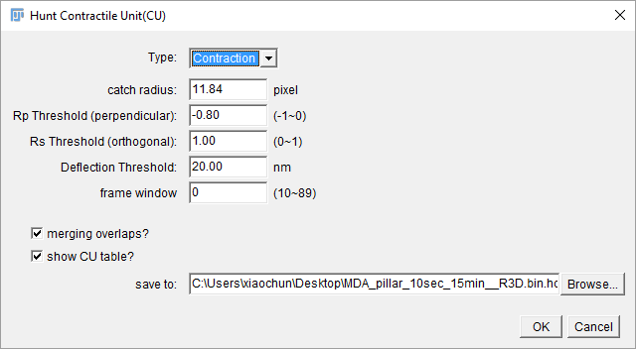 **H:\fiji_javafx\Pillar_Tracker_GUI\documentation_figures\MDA_pillar_10sec_15min__R3D-Hunt_CU.tif**

**Appendix 1: Macro Commands those could be useful for batch processing**

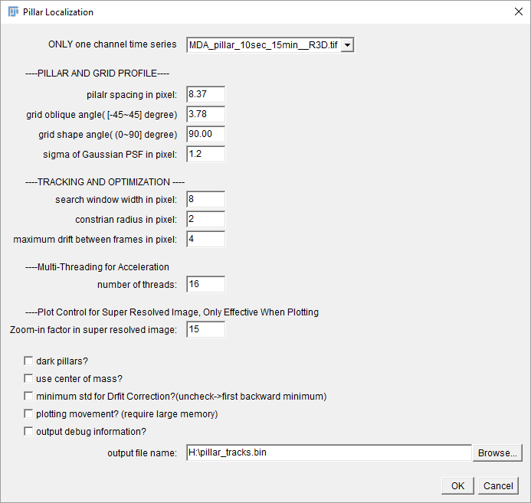

|  |
| --- |
| run("Pillar Tracking ", "only=MDA\_pillar\_10sec\_15min\_\_R3D.tif pilalr\_spacing=8.37 grid\_oblique=3.78 grid\_shape=90 sigma=1.2 search\_window\_width=8 constrian\_radius=2 maximum=4 number\_of\_threads=16 zoom-in=15 output=H:\\pillar-tracks.bin"); |

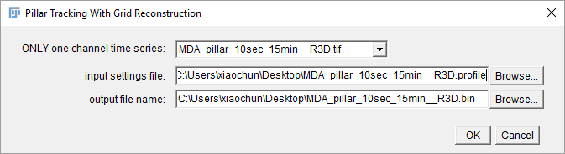

|  |
| --- |
| //apply the pillar reconstruction algorithm since v1.1.3  run("Pillar Tracking FD", "only=MDA\_pillar\_10sec\_15min\_\_R3D.tif input=C:\\Users\\xiaochun\\Desktop\\MDA\_pillar\_10sec\_15min\_\_R3D.profile output=C:\\Users\\xiaochun\\Desktop\\MDA\_pillar\_10sec\_15min\_\_R3D.bin"); |

**An Example for batch processing all TIFF files in a folder.**

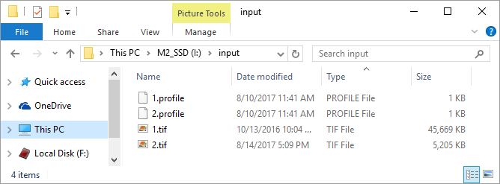

In order to create a profile file, which contains the parameters for pillar tracking, right click in the “Tracking” accordion, and then click the menu “Save Current Parameters”.

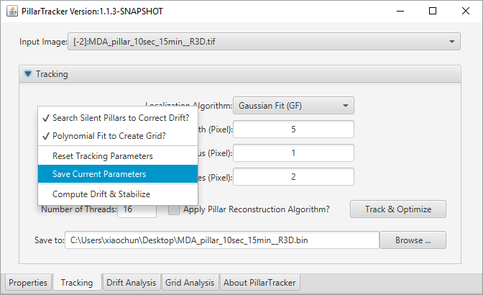

|  |
| --- |
| // "Batch Process Pillar Tracking"  //  // This macro batch processes all the TIFF files in a folder.  // for each tiff file, it will need corresponding profile file.  // the profile file contains parameters are needed for pillar tracking.  // The binary file will be saved into the same folder.  input = getDirectory("Choose Source Directory ");  if(!File.isDirectory(input)){  print("input folder doesn't exist:"+input);  exit;  }  list = getFileList(input); if(list.length<1) exit;  batchmode=false; //set true, will not show the intermediate images  setBatchMode(batchmode);  surfix = ".tif";  for(i=0; i<list.length; i++){  showProgress(i+1, list.length);  if(!batchmode) run("Close All");  filename = input + list[i];  if(endsWith(toLowerCase(filename), surfix)){  print("opening file:"+filename);  run("Bio-Formats", "open=["+filename+"] color\_mode=Default view=Hyperstack stack\_order=XYCZT use\_virtual\_stack");  img\_title = list[i];  img\_name = substring(img\_title,0,lengthOf(img\_title)-lengthOf(surfix));  fname\_profile = input+img\_name+".profile"; //filename + ".profile";  if(File.exists(fname\_profile)){  strlen = lengthOf(img\_title);  outfname = input+img\_name+".bin";  run("Pillar Tracking FD", "only=["+img\_title+"]" + " input=[" +fname\_profile+"]" + " output=["+outfname+"]");  }  }  } |

**Appendix 2: Binary File Reader for Drift Analysis in Matlab.**

This script can be also downloaded from our [GitHub repository](https://github.com/scottreen/PillarTracker).

|  |
| --- |
| %read\_pillar\_bin Read PILLAR binary data.  % [META, DATA] = read\_pillar\_bin(FILENAME) reads binary data from the  % specified file by the string FILENAME. The return value META stores  % file meta information, parameters used to generate this file. and DATA  % stores the raw coordinates, drift-corrected coordinates and  % corresponding deflections if existed.  function [file\_header, data] = read\_pillar\_bin(fname)  file\_header = struct;  data = struct;    %% open the file  fileID = fopen(fname);  readmode = 'b';    %% read header  fileversion1 = 589450; %file version control  fileversion2 = 589451; %since v1.1.3 if grid restoration applied  file\_header.version = fread(fileID,1,'int',readmode);  file\_header.npillars = 0;  file\_header.nframes = 0;  file\_header.suc\_load = false;  if(file\_header.version==fileversion1 || file\_header.version==fileversion2)  file\_header.npillars = fread(fileID,1,'int',readmode);  file\_header.nframes = fread(fileID,1,'int',readmode);  file\_header.pixel\_size = fread(fileID,1,'double',readmode);  file\_header.diameter = fread(fileID,1,'double',readmode);  file\_header.spacing = fread(fileID,1,'double',readmode);  file\_header.oblique = fread(fileID,1,'double',readmode);  file\_header.grid\_angle = fread(fileID,1,'double',readmode);  file\_header.sigma\_PSF = fread(fileID,1,'double',readmode);  file\_header.catch\_radius= fread(fileID,1,'double',readmode);  file\_header.kernel\_w = fread(fileID,1,'int',readmode);  file\_header.box\_limit = fread(fileID,1,'int',readmode);  file\_header.dark\_pillar = fread(fileID,1,'int8',readmode);  file\_header.use\_minimum\_std = fread(fileID,1,'int8',readmode);  file\_header.use\_metric\_CG = fread(fileID,1,'int8',readmode);  file\_header.use\_enhancer = fread(fileID,1,'int8',readmode);  if(file\_header.version==fileversion2)  file\_header.use\_fft = fread(fileID,1,'int8',readmode);  else  file\_header.use\_fft = 0;  end  file\_header.enhance\_loaded\_suc = true;  if(file\_header.use\_enhancer>0)  file\_header.enhancer.normalized\_cc = fread(fileID,1,'int8',readmode);  file\_header.enhancer.use\_gauss\_psf = fread(fileID,1,'int8',readmode);  file\_header.enhancer.gauss\_psf\_dark= fread(fileID,1,'int8',readmode);  file\_header.enhancer.gauss\_psf\_radius= fread(fileID,1,'int',readmode);  file\_header.enhancer.gauss\_psf\_sigma = fread(fileID,1,'double',readmode);  file\_header.enhancer.psf\_w = fread(fileID,1,'int',readmode);  file\_header.enhancer.psf\_h = fread(fileID,1,'int',readmode);  if(file\_header.enhancer.psf\_w>0 && file\_header.enhancer.psf\_h>0)  file\_header.enhancer.PSF = fread(fileID,[file\_header.enhancer.psf\_w, file\_header.enhancer.psf\_h],'double',readmode);  else  file\_header.enhance\_loaded\_suc = false;  end  end  if(file\_header.use\_fft>0)  file\_header.FFT.off\_center\_radius = fread(fileID,1,'int',readmode);  file\_header.FFT.center\_radius = fread(fileID,1,'int',readmode);  file\_header.FFT.start\_off\_center\_radius = fread(fileID,1,'int',readmode);  file\_header.FFT.end\_off\_center\_center\_radius = fread(fileID,1,'int',readmode);  file\_header.FFT.num\_points = fread(fileID,1,'int',readmode);  file\_header.FFT.points = fread(fileID,[2,file\_header.FFT.num\_points],'int',readmode);  end  if(file\_header.enhance\_loaded\_suc)  startXY= fread(fileID,[2,file\_header.npillars],'int',readmode);  file\_header.startX = startXY(1,:);  file\_header.startY = startXY(2,:);  file\_header.suc\_load = true;  end  elseif(mod(file\_header.version,2)==0)  file\_header.npillars = version/2;  file\_header.nframes = fread(fileID,1,'int',readmode);  file\_header.suc\_load = true;  end    %% check whether the file header is loaded successfully.  if(file\_header.suc\_load && file\_header.npillars>0 && file\_header.nframes>0)  %% read out the tracks  ncols = file\_header.npillars\*2;  nframes = file\_header.nframes;  A = fread(fileID,[ncols, nframes],'double',readmode);  B = fread(fileID,[ncols, nframes],'double',readmode);  if(file\_header.version==fileversion2)  %% deflections  data.DX=B(1:2:ncols,:)';  data.DY=B(2:2:ncols,:)';  %% drift corrected data  B = fread(fileID,[ncols, nframes],'double',readmode);  end    %% raw data  data.tracksX=A(1:2:ncols,:)';  data.tracksY=A(2:2:ncols,:)';    %% drift correct data  if(numel(B)>0)  data.drift\_correctX=B(1:2:ncols,:)';  data.drift\_correctY=B(2:2:ncols,:)';  % drift information  driftXY = fread(fileID,[2, nframes],'double',readmode);  data.driftX = driftXY(1,:);  data.driftY = driftXY(2,:);  % reference pillars flags  reference\_flags = fread(fileID,file\_header.npillars,'int8',readmode);  data.reference = (reference\_flags>0);  end  else  file\_header.suc\_load = false;  disp('loading file failed.');  end    %% colse the file handle  fclose(fileID);  end |

**Appendix 3: Binary File Reader for Grid Analysis in Matlab.**

Caution: since v1.1.3, this file has been merged into drift file if grid restoration is applied

|  |
| --- |
| %% clear the workspace  clear;    %% define a grid binary file path, including the deflection information.  fname = 'C:\Users\xiaochun\Desktop\MDA\_pillar\_10sec\_15min\_\_R3D.bin.dxy';  checksum0=200700; %old file version before 1.0.8  checksum1=200701;    %% open a file  fileID = fopen(fname);  readmode = 'b';    %% check the file version  version=fread(fileID,1,'int',readmode);  if(version~=checksum0 && version~=checksum1 )  disp('wrong file version');  return;  end    if(version==checksum0)  %% load the file info  lattice = fread(fileID,1,'double',readmode);  diameter = fread(fileID,1,'double',readmode);  spacing = fread(fileID,1,'double',readmode);    frames = fread(fileID,1,'int',readmode);  npillars = fread(fileID,1,'int',readmode);    %% read data  active\_lin = fread(fileID,npillars\*frames,'uint8',readmode);  num = nnz(active\_lin);  data = fread(fileID,[4, num],'double',readmode);    %% close the file  fclose(fileID);    %% load to the arrays  active = false(frames, npillars);  tracksX = nan(frames, npillars);  tracksY = nan(frames, npillars);  DX = nan(frames, npillars);  DY = nan(frames, npillars);    j=0;  n=0;  for k=1:npillars  for f=1:frames  j=j+1;  if(active\_lin(j)~=0)  n=n+1;  active(f,k) = true;  tracksX(f,k) = data(1, n);  tracksY(f,k) = data(2, n);  DX(f,k) = data(3, n);  DY(f,k) = data(4, n);  end  end  end  elseif(version==checksum1)  %% load the file info  lattice = fread(fileID,1,'double',readmode);  diameter = fread(fileID,1,'double',readmode);  spacing = fread(fileID,1,'double',readmode);  oblique = fread(fileID,1,'double',readmode);  grid\_angle=fread(fileID,1,'double',readmode);  frames = fread(fileID,1,'int',readmode);  npillars = fread(fileID,1,'int',readmode);    %% read data  active\_lin = fread(fileID,npillars\*frames,'uint8',readmode);  num = nnz(active\_lin);  data = fread(fileID,[6, num],'double',readmode);  IXY\_data = fread(fileID,[2, num],'int',readmode);  %% close the file  fclose(fileID);    %% load to the arrays  active = false(frames, npillars);  tracksX = nan(frames, npillars);  tracksY = nan(frames, npillars);  corrected\_tracksX = nan(frames, npillars);  corrected\_tracksY = nan(frames, npillars);  DX = nan(frames, npillars);  DY = nan(frames, npillars);  j=0;  n=0;  for k=1:npillars  for f=1:frames  j=j+1;  if(active\_lin(j)~=0)  n=n+1;  active(f,k) = true;  tracksX(f,k) = data(1, n);  tracksY(f,k) = data(2, n);  corrected\_tracksX(f,k) = data(3, n);  corrected\_tracksY(f,k) = data(4, n);  DX(f,k) = data(5, n);  DY(f,k) = data(6, n);  end  end  end  %% load the index  IX = nan(frames, npillars);  IY = nan(frames, npillars);  n=0;  for k=1:npillars  for f=1:frames  if(active(f,k))  n=n+1;  IX(f,k) = IXY\_data(1, n);  IY(f,k) = IXY\_data(2, n);  end  end  end  end    %% plot first frame  x = tracksX(1, :);  y = tracksY(1, :);  scatter(x,y,'x'); |

**Appendix 4: Binary File Reader for Contractile Unit (CU) in Matlab.**

|  |
| --- |
| %% clear the workspace  clear;    %% define a CU binary file path, including contractile unit (CU) information.  fname = 'C:\Users\xiaochun\Desktop\MDA\_pillar\_10sec\_15min\_\_R3D.bin.hcu';  checksum0=332571;    %% open a file  fileID = fopen(fname);  readmode = 'b';    %% check the file version  version=fread(fileID,1,'int',readmode);  if(version~=checksum0)  disp('wrong file version');  %% close the file  fclose(fileID);  return;  end    if(version==checksum0)  %% load the file info  catch\_radius = fread(fileID,1,'double',readmode);  threshold\_rp = fread(fileID,1,'double',readmode);  threshold\_rs = fread(fileID,1,'double',readmode);  threshold\_deflection = fread(fileID,1,'double',readmode);  frame\_window = fread(fileID,1,'int',readmode);  merging\_overlaps = fread(fileID,1,'int8',readmode);    %% read data  num = fread(fileID,1,'int',readmode);  ContractionUnit = cell(num, 6);  for i=1:num  ContractionUnit{i,1} = fread(fileID,1,'int',readmode);  ContractionUnit{i,2} = fread(fileID,1,'int',readmode);  ContractionUnit{i,3} = fread(fileID,1,'int',readmode);  ContractionUnit{i,4} = fread(fileID,1,'int',readmode);  ContractionUnit{i,5} = fread(fileID,1,'double',readmode);  ContractionUnit{i,6} = fread(fileID,1,'double',readmode);  end  %% close the file  fclose(fileID);  end |